FAIR Process Framework - Workbook 2
Persona Archetype Examples

Persona Mapping
Innovator
Lead Organization Representative
Project Officer
Researcher
Project Partner
Third Party Publisher
Complete the profile of each Persona in the spaces below with
the Persona type, the name of a particular individual (if applicable),
the organization, and any additional comments.
Example:
Lead Organization
He Lijing
AgriConnect
Implementation lead, based in Dataland
Persona Type:_________________________________
Name: _______________________________________
Organization: _________________________________
Comments: ___________________________________
Persona Type:_________________________________
Name: _______________________________________
Organization: _________________________________
Comments: ___________________________________
Persona Type:_________________________________
Name: _______________________________________
Organization: _________________________________
Comments: ___________________________________
Persona Type:_________________________________
Name: _______________________________________
Organization: _________________________________
Comments: ___________________________________
Persona Type:_________________________________
Name: _______________________________________
Organization: _________________________________
Comments: ___________________________________
Persona Type:_________________________________
Name: _______________________________________
Organization: _________________________________
Comments: ___________________________________
Persona Type:_________________________________
Name: _______________________________________
Organization: _________________________________
Comments: ___________________________________
Persona Type:_________________________________
Name: _______________________________________
Organization: _________________________________
Comments: ___________________________________
Persona Type:_________________________________
Name: _______________________________________
Organization: _________________________________
Comments: ___________________________________
Persona Type:_________________________________
Name: _______________________________________
Organization: _________________________________
Comments: ___________________________________
Persona Type:_________________________________
Name: _______________________________________
Organization: _________________________________
Comments: ___________________________________
Persona Type:_________________________________
Name: _______________________________________
Organization: _________________________________
Comments: ___________________________________

Value Exchange
Data
Raw Data
Collected Data
Value Exchange Examples
Derived Data
Open Source Code
Insights
Funding
Advice
Reports
Capacity Development
Complete the boxes below with the Value Exchanges relevant to your investment ecosystem, including the Personas that are on the receiving and sending end of each.
Types:
Personas Involved

Types:
Personas Involved

Types:
Personas Involved

Types:
Personas Involved

Types:
Personas Involved

Types:
Personas Involved

Remote sensor.
Innovator
Example:
Data
Types:
Personas involved:

Types:
Personas involved

Types:
Personas involved
Types:
Personas involved:

Types:
Personas involved

Types:
Personas involved
Types:
Personas involved:

Types:
Personas involved

Types:
Personas involved

Enabling and Inhibiting Factors
Inhibiting Factor Examples
Enabling Factor Examples
Unstable political
environmental
Lack of data
regulation
Weak digital
infrastructure
Cultural practices
and beliefs
Lack of data
sharing culture
Low access to
technology
Strong political, legal,
regulatory frameworks
Data sharing norms
Robust digital
infrastructure
Cultural practices
and beliefs
Widespread
digital literacy
Access to technology
among users
Fill in the boxes below with the Factors present in your investment's ecosystem. Consider which Personas and Value Exchanges will be enabled or inhibited as a result.
Strong public opposition to data sharing practices rooted in cultural beliefs. Blocking research and development work.
Researcher, Innovator
Description:
Personas involved:
Value exchanges involved:
Example:
Example:
Description:
Personas involved:
Value exchanges involved:
Description:
Personas involved:
Value exchanges involved:
Description:
Personas involved:
Value exchanges involved:
Description:
Personas involved:
Value exchanges involved:
Description:
Personas involved:
Value exchanges involved:
Description:
Personas involved:
Value exchanges involved:
Description:
Personas involved:
Value exchanges involved:
Description:
Personas involved:
Value exchanges involved:
Description:
Personas involved:
Value exchanges involved:
Description:
Personas involved:
Value exchanges involved:
Description:
Personas involved:
Value exchanges involved:
Inhibiting Factors
Enabling Factors

Robust data sharing framework setting norms for data privacy
and access
Private sector
project partner (supplying data)
Data,
derived data, insights (TBC), raw data

Collected data, Insights

Data Ecosystem Map
Based on your answers from the previous three worksheets,
unite the various components of your investment's ecosystem
on this map.
Include the Personas in the blue circles, draw the Value Exchanges
passing between them, and indicate where the Enabling and
Inhibiting Factors may come into play.
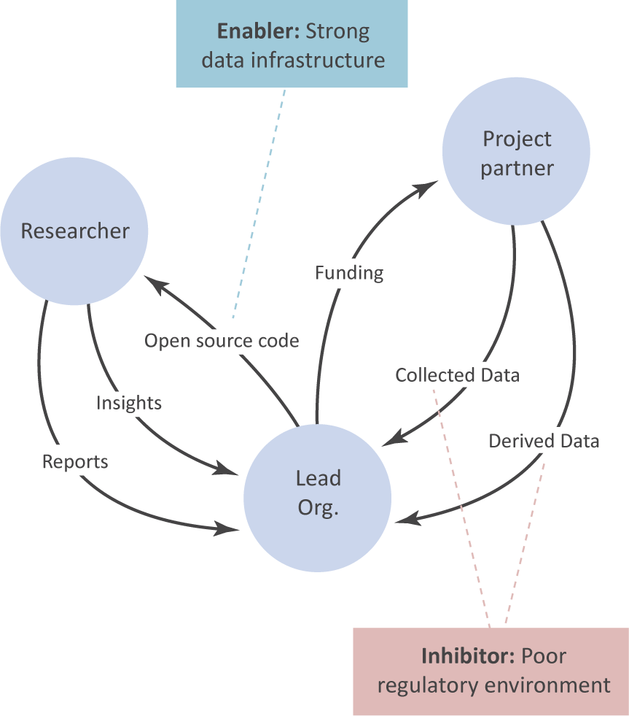
Example:

